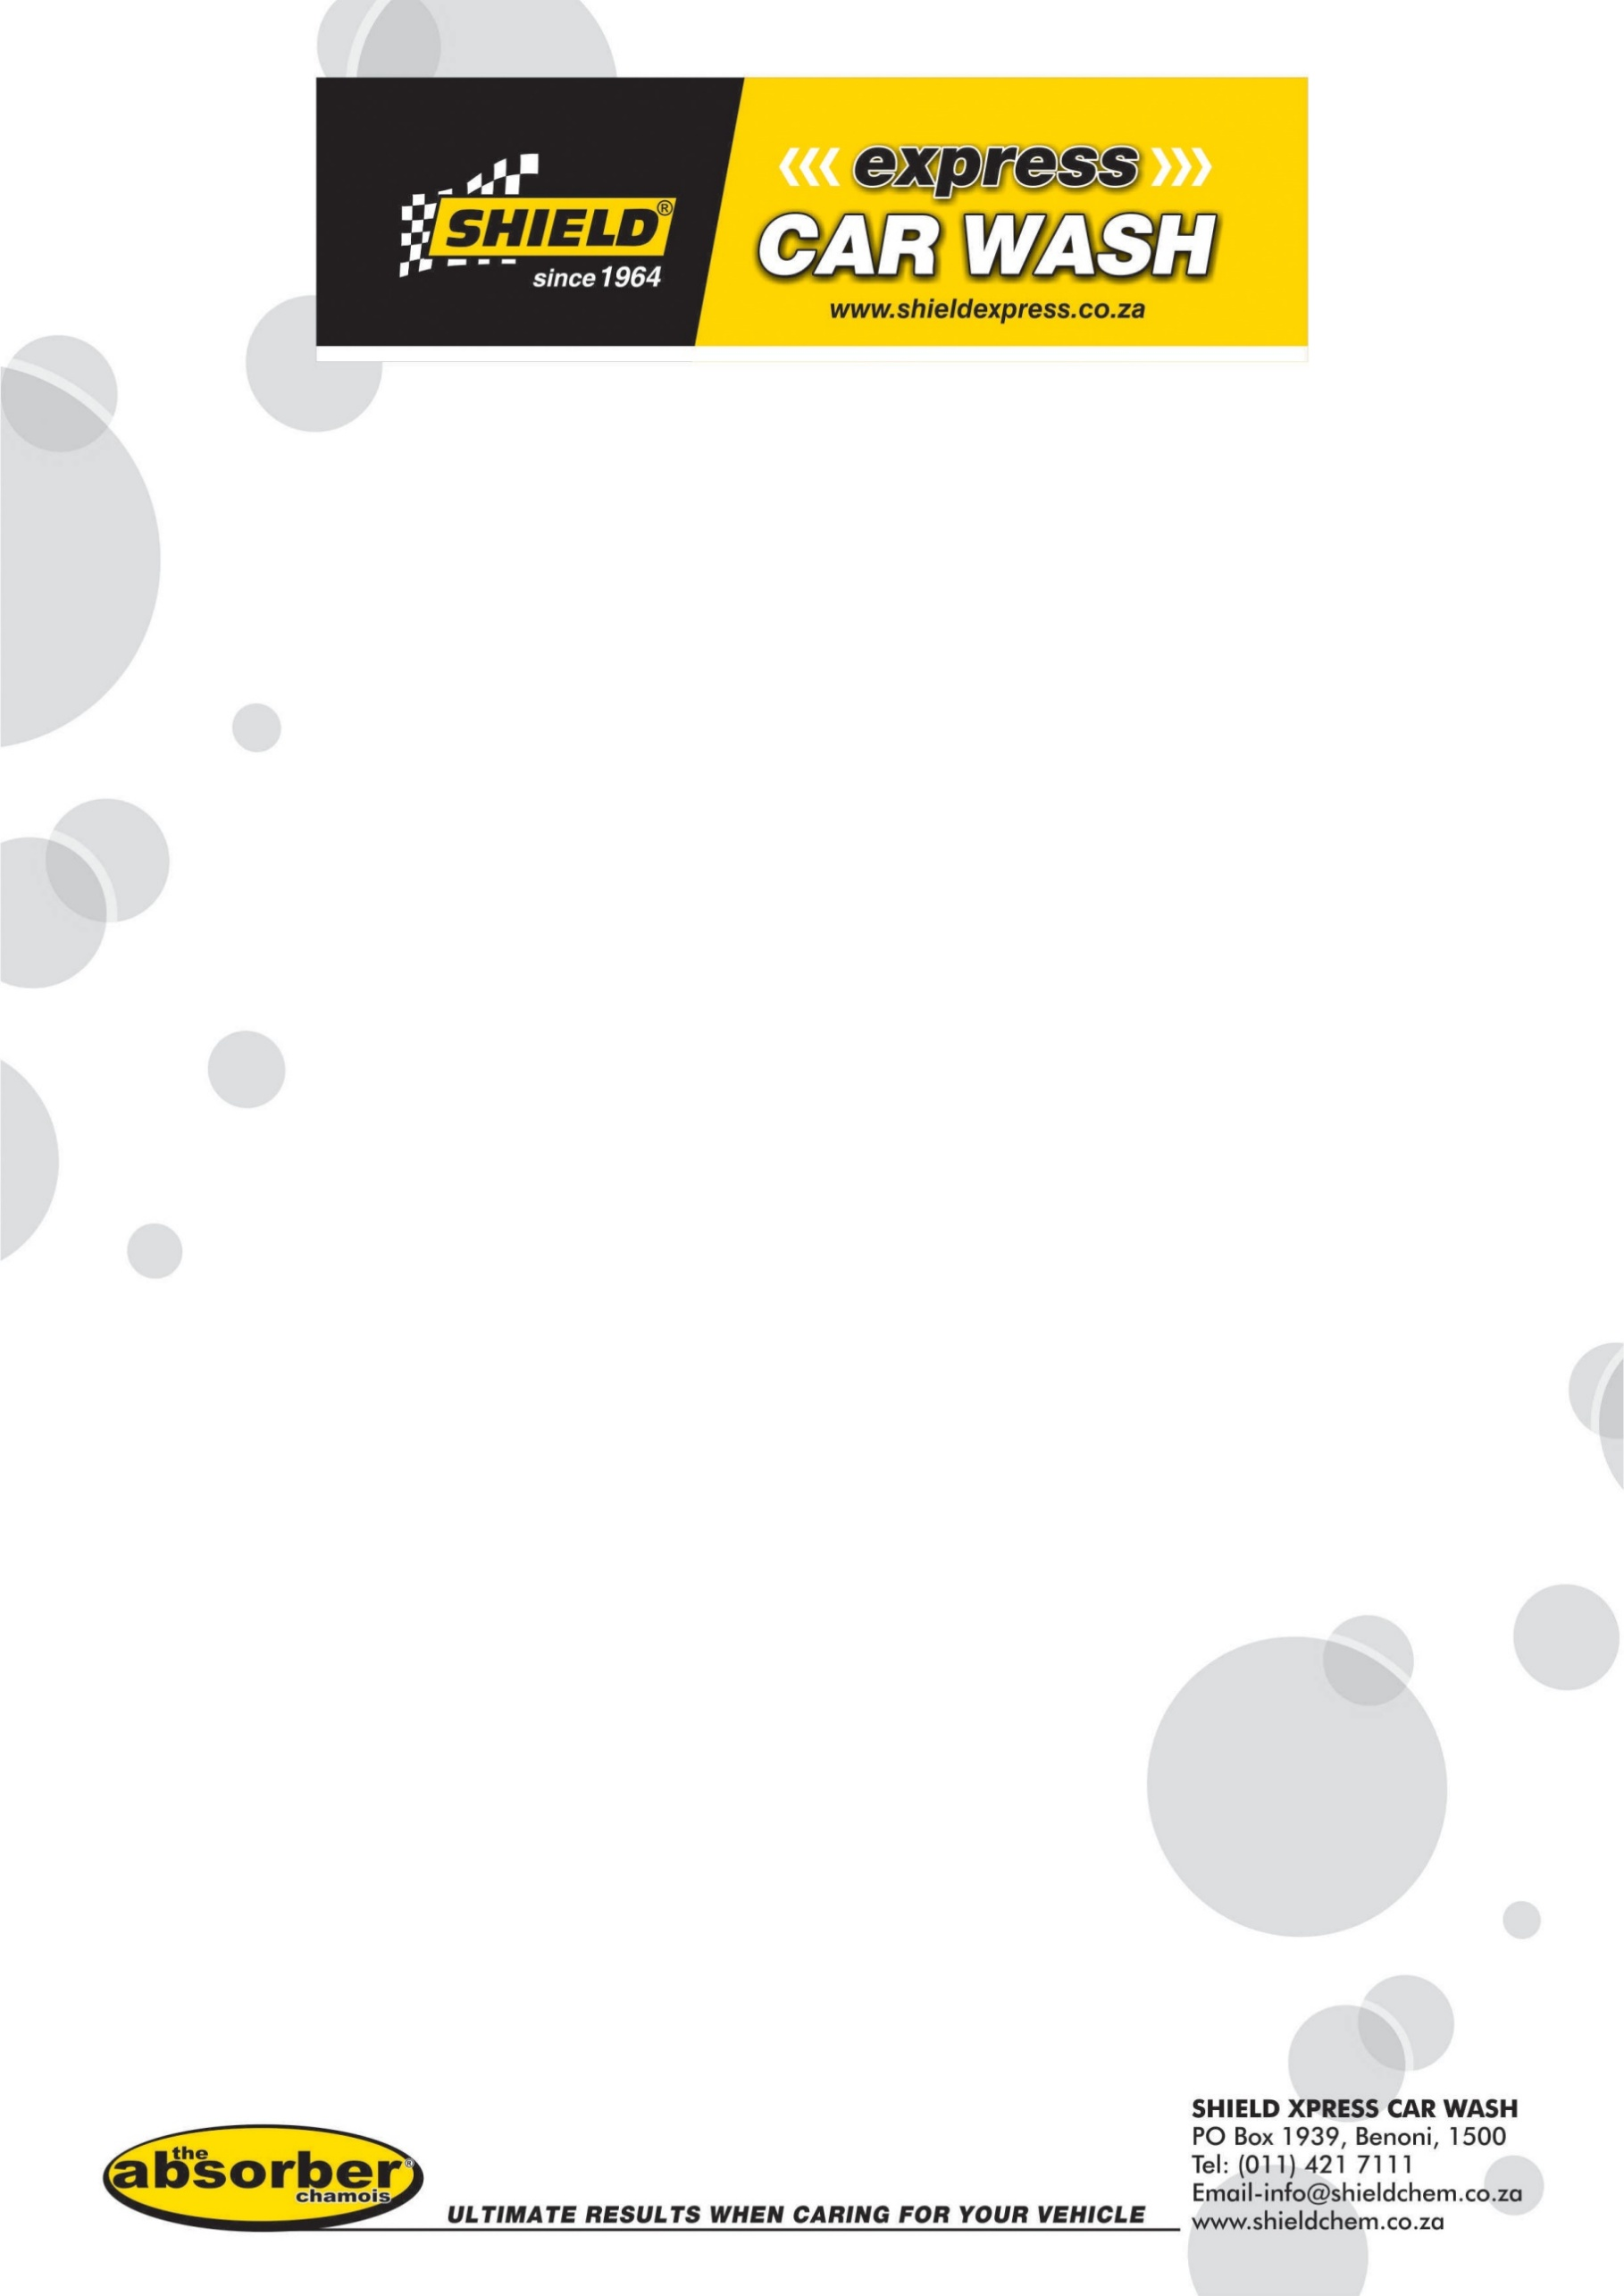
THE SHIELD EXPRESS CAR WASH FRANCHISE APPLICATION PROCESS
The SHIELD EXPRESS CAR WASH (SHIELD ECW) Franchise Application process is a one which is followed to maintain and uphold the integrity of the SHIELD ECW brand. SHIELD ECW is committed to franchising as part of our way of doing business. We follow a strict application procedure and all applications are processed on a first received basis.
Here are a few basic questions for potential Applicants to answer:
- Do you truly want to run your own service orientated business?
- Do you have sufficient liquid capital, a good reputation and a clean credit record?
- Are you willing to train in all aspects of running a business the SHIELD ECW way?
- Are you willing to operate a business under a set of laid down rules, systems and culture?
- Do you enjoy working with a team of people and being their leader?
If you cannot answer yes to all of the above questions then SHIELD ECW is not the right choice for you. However, if you can, read on.
We are looking for Franchisees with the following qualities:
- Highly professional business ethics and strong personal integrity.
- A business background, with special emphasis on interpersonal skills, team leadership and financial management.
- An entrepreneurial spirit and strong desire to succeed.
- The ability to meet the financial requirements.
- Excellent communicator, exhibiting respect and courtesy at all times.
- Willingness to devote time and effort to the day-to-day operation of the SHIELD ECW store.
- A strong personal support structure.
Application Rules and Processes
- Submission of a franchise application pack does not guarantee that a franchise will be awarded to the Applicant.
- Submission of a franchise application pack does not guarantee that the Applicant will be given the opportunity to have a meeting/interview (telephonic and/or other) with SHIELD ECW.
- If the Applicant is afforded the opportunity to have a meeting/interview with SHIELD ECW, this still does not guarantee that a franchise will be awarded to the Applicant.
- If the Applicant is not awarded a franchise, SHIELD ECW is not obligated to give details as to why the application was unsuccessful and SHIELD ECW will not enter into discussions and/or correspondence regarding its decision to reject the Applicant.
- Applicants must be prepared to wait for an available opportunity and/or a SHIELD ECW approved site, which can take some time.
- The submission of any information to SHIELD ECW or associated companies places no obligation on SHIELD ECW.
- A pre-requisite of the approval of an Applicant is that he/she must avail him/herself for a face to face interview at SHIELD ECW Head Office in Benoni.
A total commitment of personal time and energy is of utmost importance. The Applicant must be willing to work hard and concentrate exclusively on the challenge of operating the business.
Operational Requirements
Each Applicant must have a person/s on his/her team with management experience or proven executive leadership skills. That person/s must have extensive experience in operations with a history of superior customer service and quality business management, or proven executive and leadership skills, and must also reside within an easy commute of the business and have a good knowledge of the local area.
Financial Requirements
Applicants are required to have a minimum of 50% of the total cost of the investment as liquid capital i.e. as unencumbered cash and it is always preferable for Applicants not to have to raise finance at all for the total cost of the investment.
Stage One: Our Initial Requirements – Application Procedure
If you’re interested in applying for a SHIELD ECW Franchise, please complete and submit all of the following:
- SHIELD ECW Franchise Application consisting of 3 parts
  - Part 1: Franchise Application Form
  - Part 2: SHIELD ECW Agreement of Confidentiality and Non-Disclosure (each page must be initialed for the franchise application pack to be processed)
  - Permission to Perform a Credit Check.
- Copy of your Identity Document
Collectively called, “the franchise application pack”
The franchise application pack is to be submitted via email to franchise@shieldchem.co.za
Stage Two: Formal Application Process
Once we receive the franchise application pack, we’ll begin to process it. This usually takes 2 to 3 weeks. If the franchise application pack meets our criteria and we believe that you would be an ideal fit for our brand, we’ll require proof of your availability to pay for the investment. Following this, a meeting may be set up between yourself and our Franchising Department and matters will be taken from there.
Please note that given the volume of applications which we may receive, submission of the franchise application pack doesn’t guarantee that a SHIELD ECW Franchise will be awarded to you. It also doesn’t guarantee that you’ll be afforded a telephonic and/or other meeting with our Franchising Team.

Costs Structure: -
These figures are subject to change as equipment price changes. In addition, they DO NOT include VAT, or any site specific construction which are very site dependent and/or miscellaneous costs. They exclude the water recycling equipment as it’s not a necessity and the majority of people do not want to invest into this upfront. The current cost of the water recycling plant is around 13000 (Thirteen Thousand Euro) Which is imported from Europe. This can result in a recovery of up to 60% of your water.
We have 4 different construction design, which sometime can be site dependent and can be at the franchisee’s request.

